Denoising Medical Imaging using Multiwavelet Transformation

Removing noise from a medical image is practically useful. For image denoising it is good to use Mutliwavelet transformation as opposed to simple Wavelets, because the Mutliwavelets allow for multiple scaling and wavelet functions to be applied at once. In addition, the Mutliwavelets can offer Orthogonality, Symmetry, and Short support, which simple scalar wavelets cannot. The purpose of this paper is to apply different ways of using multiwavelets in order to achieve a medical image denoising and ultimately bring glory to the Lord Christ, who created these technologies.

1. Introduction

Digital images are wide spread with the advancement of technologies throughout the world. People use images to capture memorable moments, analyze body parts, explore space, and much more. However, in sensitive imaging like MRI or CAT scans the data is often presented with noise. This is usually caused by faulty instruments, which makes an image not so clear to the human eye. Noise can also come to be in the image through compression or some transmission error. So, image denoising is a necessary first step in its processing. Denoising, however, can add blur to an image, which might be problematic when analyzing it. In this paper we will present some noise reduction methodologies, comparing their effectiveness and drawing conclusions from them. Different methods are applied to different noise models. The most common type, though, is additive random noise, modeled as a Gaussian noise.

Multiwavelets now allow for simultaneous orthogonality, symmetry and short support, which was earlier impossible with simple wavelets. This makes multiwavelets better fit for denoising.

Recently it has been proposed to filter additive white Gaussian noise by thresholding the decomposed coefficients. A given coefficient is set under a threshold, is set to 0 if its magnitude is less than the threshold, else is kept as it was.

Denoising procedure is described on Figure 1, as well as below:

1. A medical tomography image of the head gets additive Gaussian noise applied to it;
2. Prefiltering is done by converting the scalar coefficients into vector ones for Multiwavelet decomposition;
3. Applying different mutliwavelets like GHM or CL with their transforms to the image;
4. Applying multiwavelet thresholds like soft, hard, universal, modified, fixed and mutlivariative thresholds;
5. By applying inverse mutliwavelet transforms to the thresholded coefficients we get a denoised vector output image.

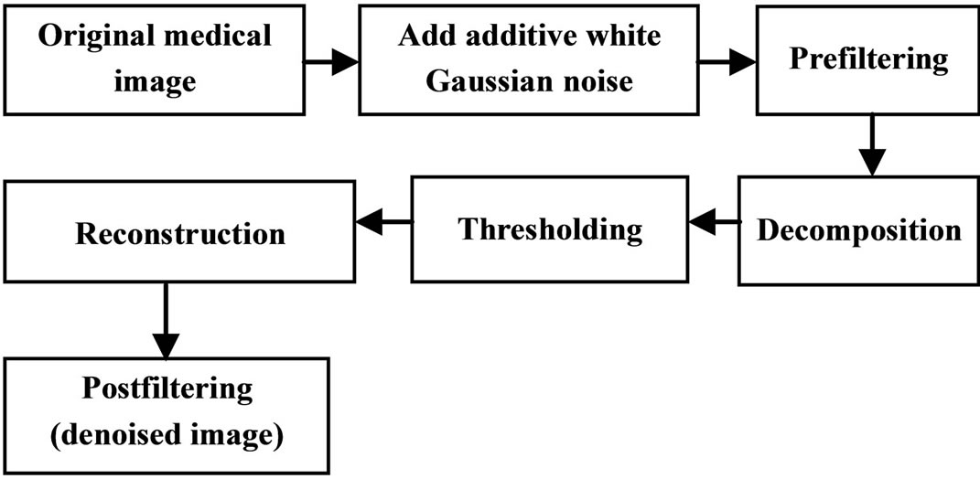
Figure 1. Denoising using Multiwavelet transformation

2. Theory on Multiwavelets

The idea of multiwavelets originated from the generalization of scalar (regular) wavelets. For scalar wavelets we have one scaling and one wavelet function, but for multiwavelets we have multiple scaling and wavelet functions. Therefore properties like orthogonality, symmetry, higher order of vanishing moments, and others can be presented in multiwavelets. The multiwavelets can be of two types:

1. Orthogonal, like Geronimo-Hardin-Massopust (GHM), Symmetric Assymetric (SA4);
2. BiOrthogonal, like BiOrthogonal Hermine (Bih52S).

The scaling functions are symmetrical, and have a short support. Multiwavelets are characterized with several scaling functions and associated wavelet functions, like:

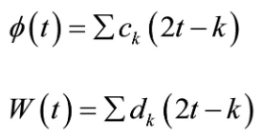

The sub-bands of a single Multiwavelet are shown on Figure 2.2. Here, the f(t) is a multiscaling function, and W(t) is a multiwavelet function.

A multi filter has two or more low pass filters. The purpose is to achieve the following properties:

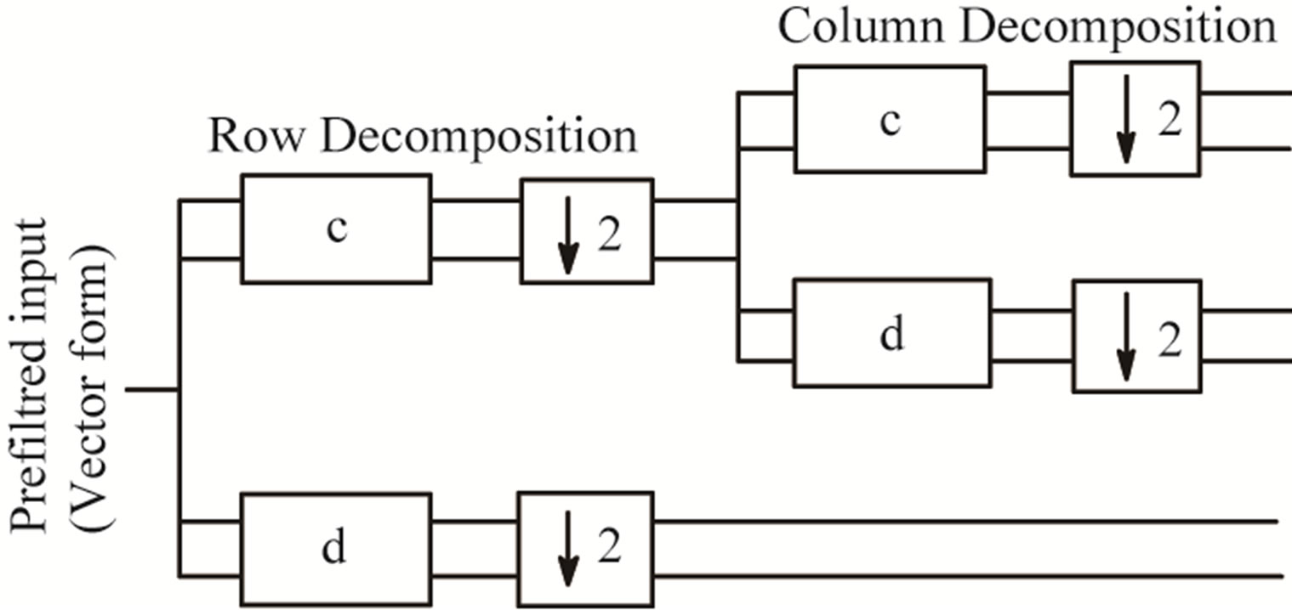
Figure 2.1 Multifilter bank with low pas filter iterated once.

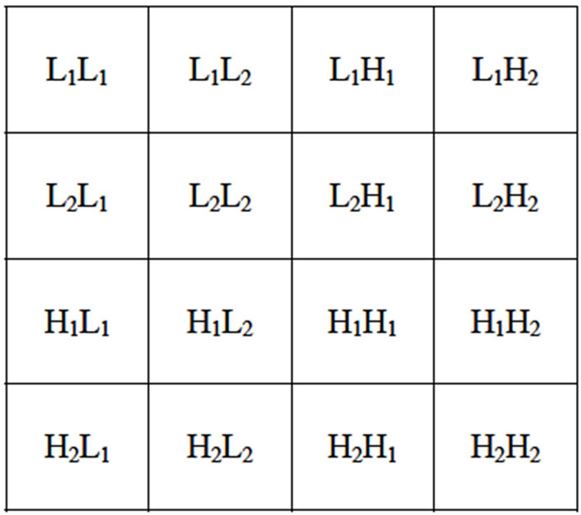
Figure 2.2 Image sub-bands after one level of Multiwavelet decomposition

Properties of F1 and F2

The main properties of those two functions are as follows:

1. Symmetry: f1 and f2 have linear phase, they are even functions;
2. Short Support: Fi ends outside the interval [0,i]. Short support doesn’t have boundary problems. The long support modifies the function near boundaries. Wavelets have long support to achieve orthogonality.
3. Second Order Accuracy: The scaling functions have second order accuracy, that sets up two vanishing moments.
4. Orthogonality: The translates f1(t-k) & f2(t-k) are all mutually orthogonal.
5. Matrix Multiscaling (Dilation) and Multiwavelet Equations: The coefficients “ck” and “dk” are 2 by 2 matrices, multiplying vectors of scaling and wavelet functions as given in the following equations:

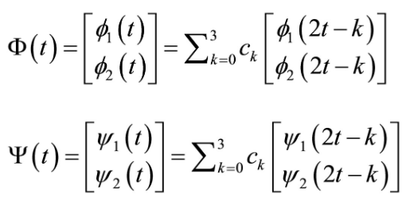
Figure 2.3 Functions for the coefficients.

3. Thresholding Technique
3.1 Hard thresholding

Hard thresholding chooses coefficients greater than some lambda threshold, but sets other to 0. This, however, is not efficient for removing large noise coefficients. The hard threshold is defined in the equation below:

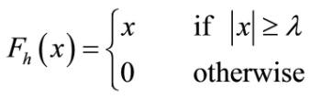

The transfer function for this method is shown on Figure 3.2. And if the coefficient is greater than lambda, the value is attributed to the original pixel, but if not, then it will be classified as noise and discarted.

3.2 Soft Thresholding

This method is preferred over hard thresholding and yields better results. Soft thresholding shrinks the coefficients by the threshold toward zero. This is also sometimes called shrinkage function. This method is defined on the equation below:

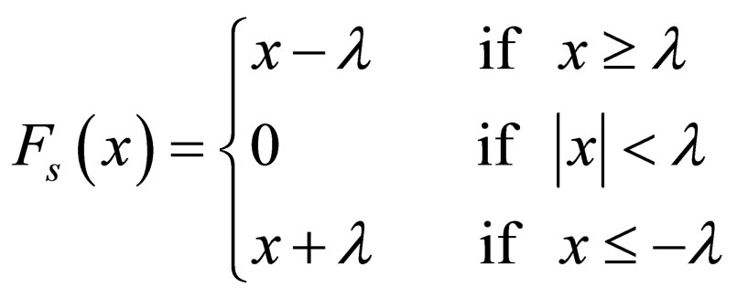

The transfer function for this method is defined on Figure 3.3.

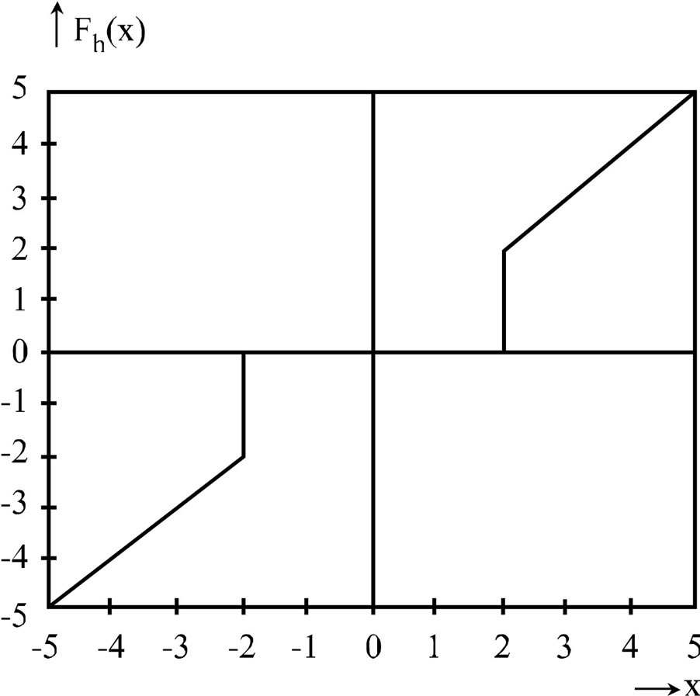
Figure 3.2. Hard thresholding

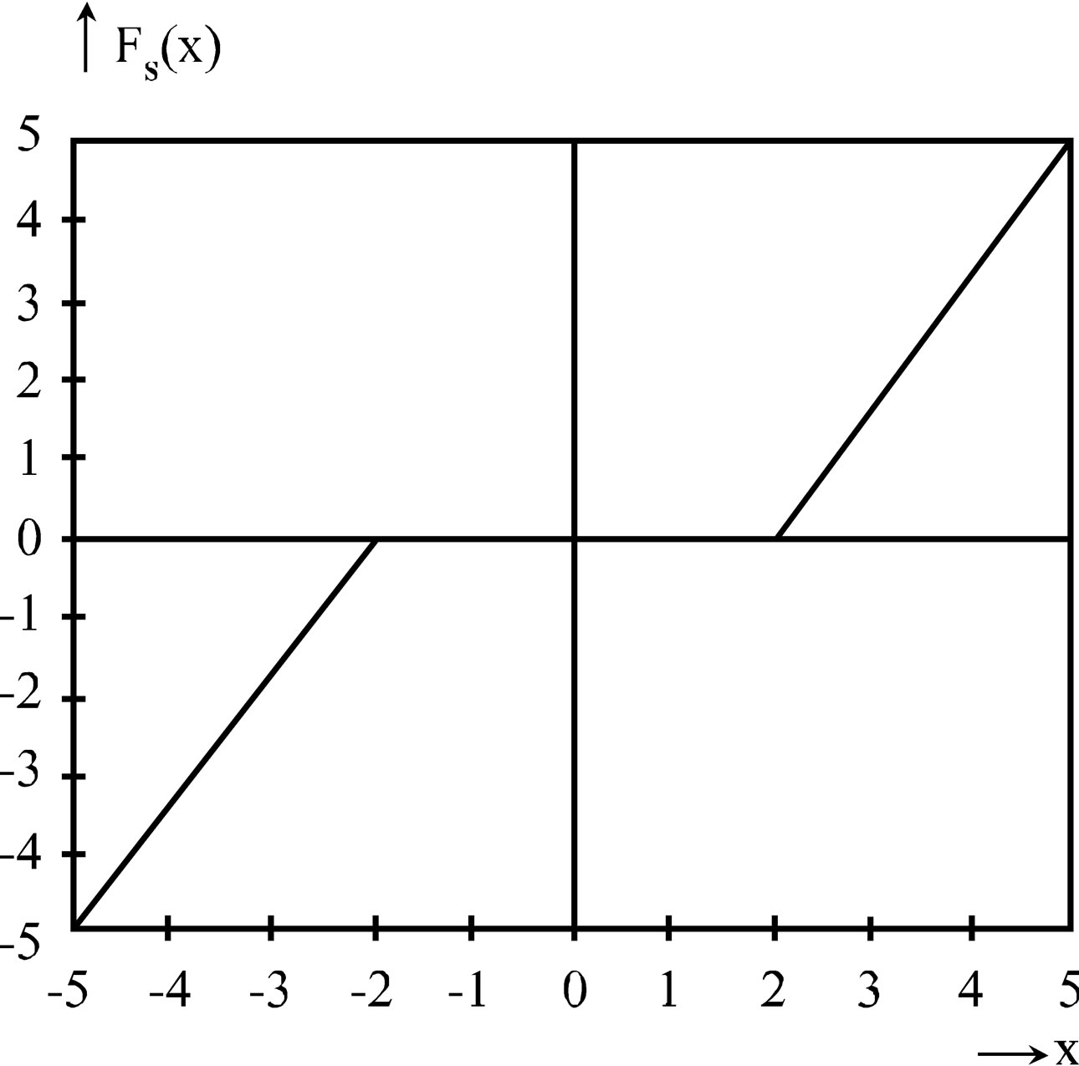
Figure 3.3 Soft thresholding

3.3 Wavelet Thresholding

Noise is prevalent among higher order frequencies that are obtained after Mutliwavelet (or simple wavelet) decomposition. Wavelet thresholding is a special estimator technique that exploits the capabilities of wavelet transforms. In this case the coefficients dominated by noise are set to 0, considering they are below a threshold. This removes noise.

3.3.1 Universal Threshold

This universal threshold was first introduced for scalar wavelets. It’s equation is as follows:

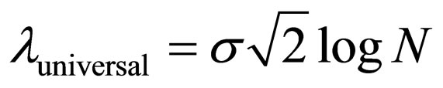

where sigma is the standard deviation of the noise, N is the sample data.

The same threshold is applied to all coefficients, no matter their decomposition level. For imaging N is chosen as the number of pixels in a row, as opposed to setting it to the total amount of pixels in the image. This is done because, after some observation, such technique results in lower Sound-to-Noise Ratios.

3.3.2 Modified Universal Threshold

The formula for it is given in equation:

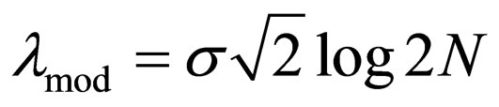

where sigma is the standard deviation of the noise, and N is the sample size.

Another option for this method is given in an equation below:

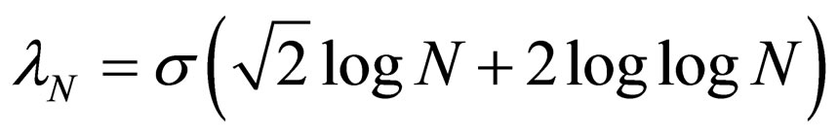

3.3.3 New Thresholding

The equation for this kind of method is as follows:

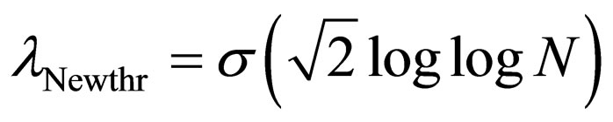

3.4 Measuring Parameters
3.4.1 Mean Square Error (MSE)

The formula on how to measure a mean square error between the original image I(x,y) and the reconstructed image I’(x,y) is given below:

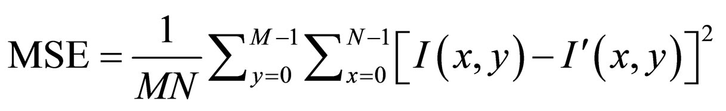

where I(x,y) is the given image, I’(x,y) is the approximated version, and M*N is the size on an image.

3.4.2 Signal-to-Noise Ratio (SNR)

This equation is used to compare how well the reproduced image was made.

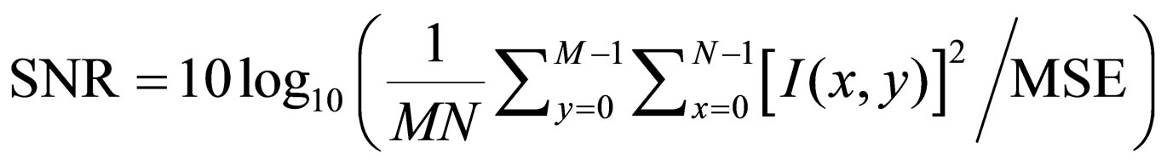

3.4.3 Peak Signal-to-Noise Ratio (PSNR)

This one is a more subjective qualitative measurement of distortion, here’s the equation for an 8-bit image:

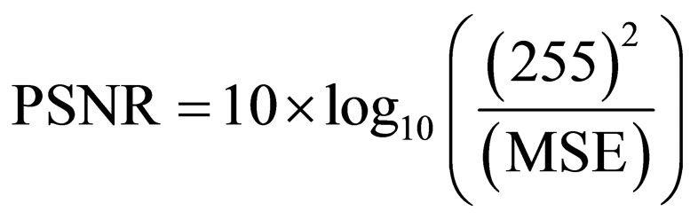

3.5 Experimental Results

So, the given methods like MSE, RMSE, PSNR and SNR measured parameters for various Multiwavelet transforms using repeated row prefiltering and thresholding techniques, and are shown in Table 1.

3.5.1 Using Repeated Row Pre-Filtering Method

The reasults of measuring parameters such as MSE, RMSE, PSNR, and SNR on multiple Multiwavelet transforms with approximation prefilter and threshold techniques are shown in Table 2.

3.5.2 Using Approximation Pre-Filtering Method

The measurements like MSE, RMSE, PSNR, and SNR values for GHM Multiwavelet transforms with various thresholding techniques are shown in Table 3.

Measurements like MSE, RMSE, PSNR, SNR for GHMAP Multiwavelet transforms with various thresholding techniques are shown in the Table 4.

The measurements of parameters like MSE, RMSE, PSNR and SNR for CARDBAL2 Multiwavelet transforms with various thresholding techniques are shown in Table 5.

Denoising of tomographic images of phantom is shown on Figure 4.

Comparison of various Multiwavelet transformations using thresholding techniques with respect to parameters like MSE, SNR, RMSE are shown on Figures 7-9 respectively.

A comparison between various Multiwavelet transforms along with various thresholding techniques is given on Figure 11 and a comparison of various Multiwavelet transforms are given on Figure 12.

3.6 Conclusions

By God’s grace, Multiwavelets gave an opportunity to construct wavelet systems that are simultaneously orthogonal, symmetric and Finite in their Impulse Response. In the process of implementation it got clear that the implementation of discrete Multiwavelet transforms does not require prefilters. We investigated the performance of Multiwavelets with different thresholding methods. Furthermore, we have modified a thresholding method in order for it to give a higher performance for the tomographic images used in our algorithms and called it a new threshold.

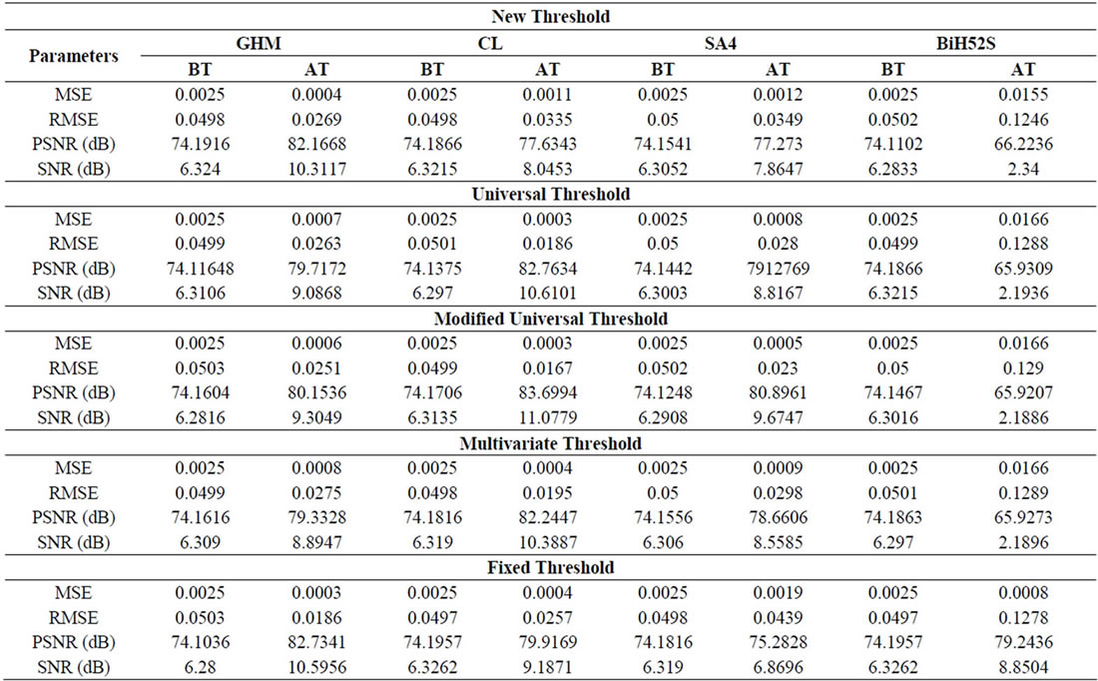
Table 1. Measurements of denoising parameters using various Multiwavelet transformation with repeated row prefilter and thresholding techniques

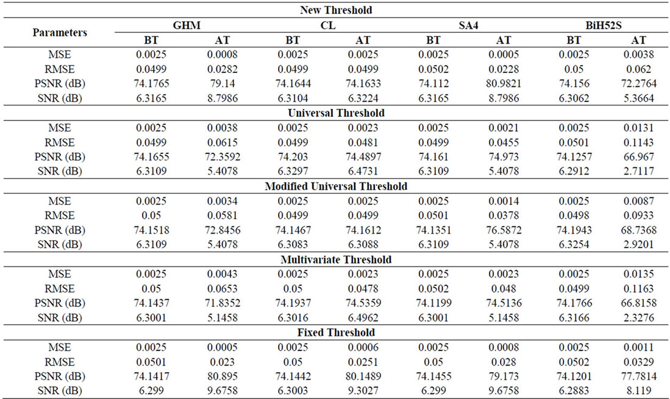
Table 2. Measuring denoising parameters using Multiwavelet transformation and approximation prefilter and thresholding techniques.

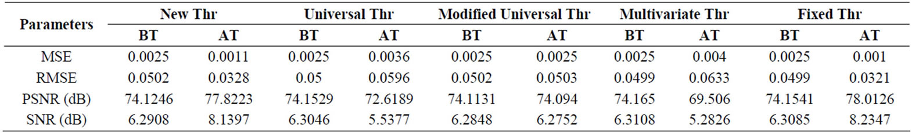
Table 3. Measurements of denoising parameters using direct Multiwavelet transofrm (GHM) using various thresholding techniques.

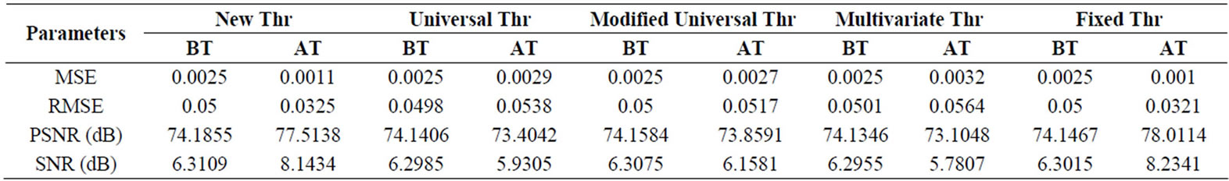
Table 4. Measurements of denoising parameters using direct Multiwavelet transform (GHMAP) using various thresholding.

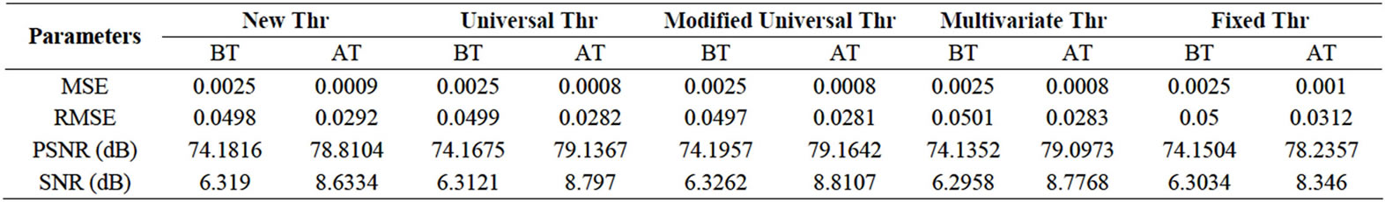
Table 5. Measurement of denoising parameters using Multiwavelet transform (CARDBLA2) with identity prefilter using various thresholding.

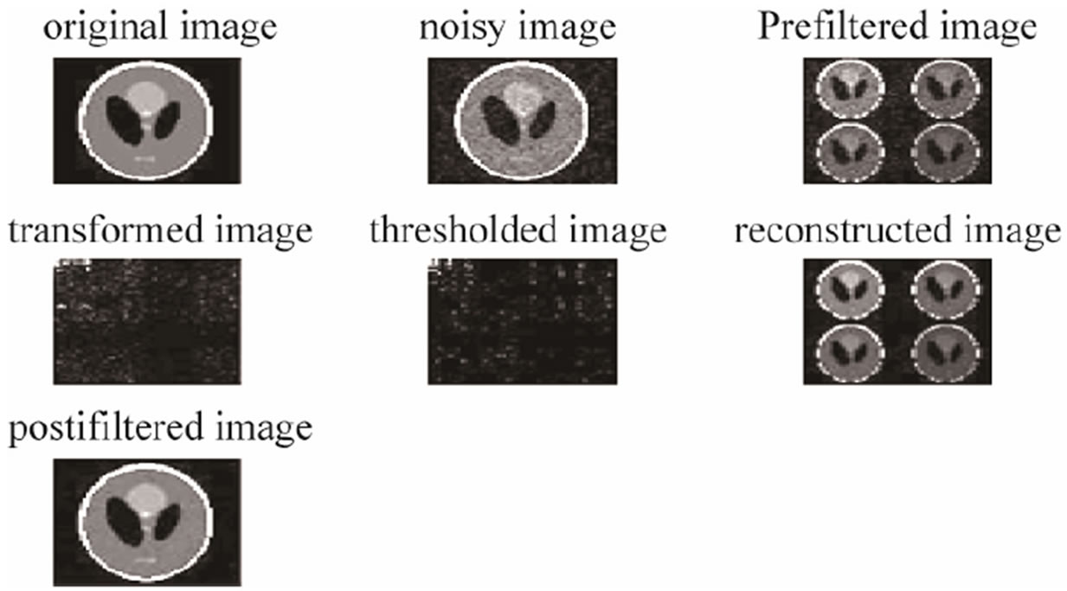
Figure 4. Denoising of phantom with Multiwavelet transformation and thresholding techniques

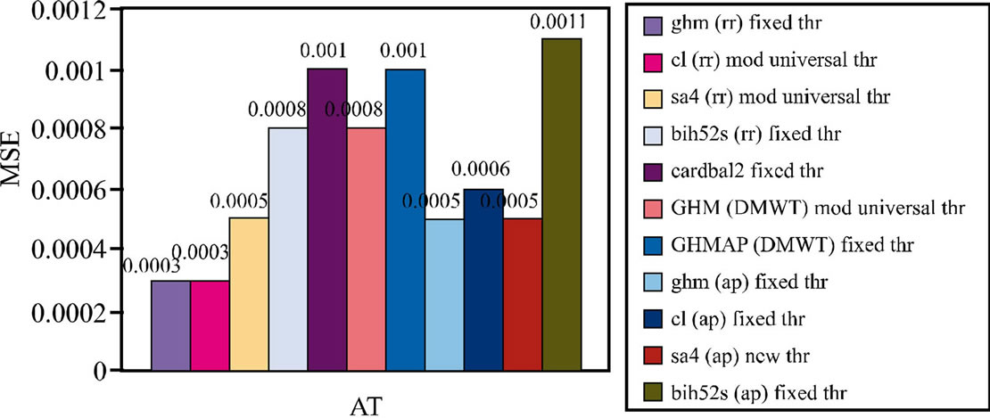
Figure 5. Comparing multiple Multiwavelet transformation with thresholding techniques using respect to Mean Square Error

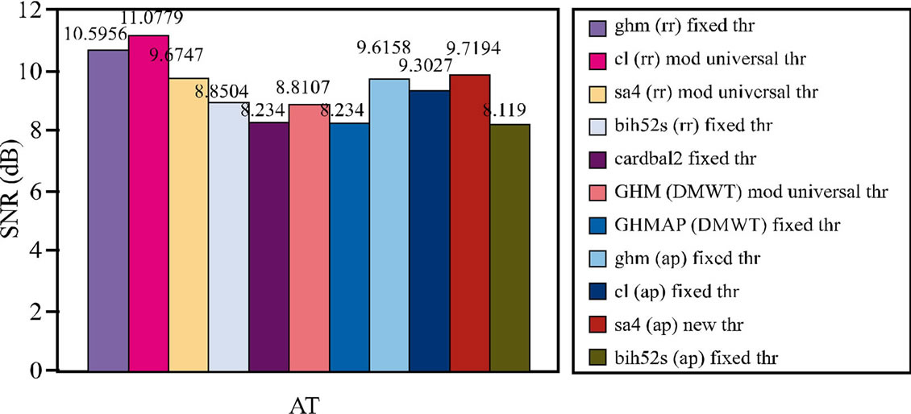
Figure 6. Comparing multiple Multiwavelet transformation with thresholding techniques using respect to Signal-to-Noise Ratio

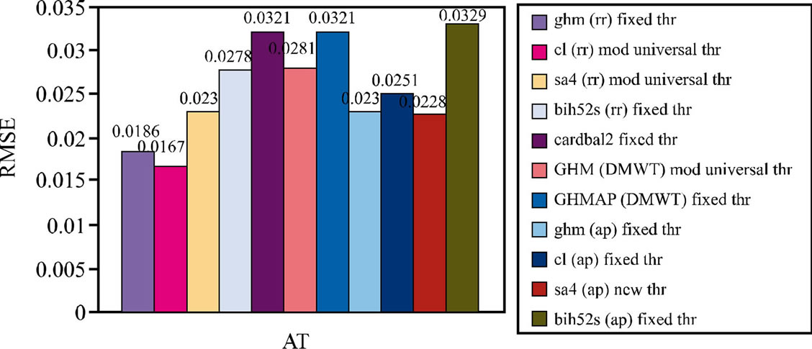
Figure 7. Comparing various Multiwavelet transformation methods using thresholding techniques with respect to Root Mean Square Error

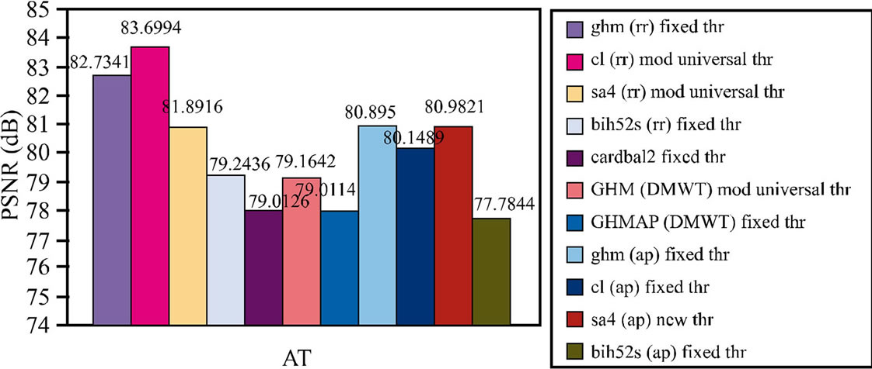
Figure 8. Comparing of various measuring parameters before and after thresholding

For further testing we have added some Gaussian noise to the 256 x 256 gray image phantom to get the noisy image, then applied different Multiwavelet transform and thresholding techniques to get a denoised image. In this paper different Multiwavelets like GHM, SA4, CL Bi-Hermite, and Multiwavelet transforms like Dec_2D, GHM and GHMAP with approximation and repeated row prefilters, as well as various thresholding techniques like universal threshold, modified universal threshold, new threshold, multivariate threshold and fixed threshold are used to denoise the testing image. Noise estimation parameters like Root Mean Square Error (RMSE), Mean Square Error (MSE), Peak Signal-to-Noise Ratio (PSNR) and Signal-to-Noise Ratio (SNR) are used to evaluate the algorithms’ performace.
At last, we have compared the different Multiwavelets and thresholding techniques. In conclusion, CL is the best Multiwavelet when used with modified universal threshold and repeated row prefilter.

